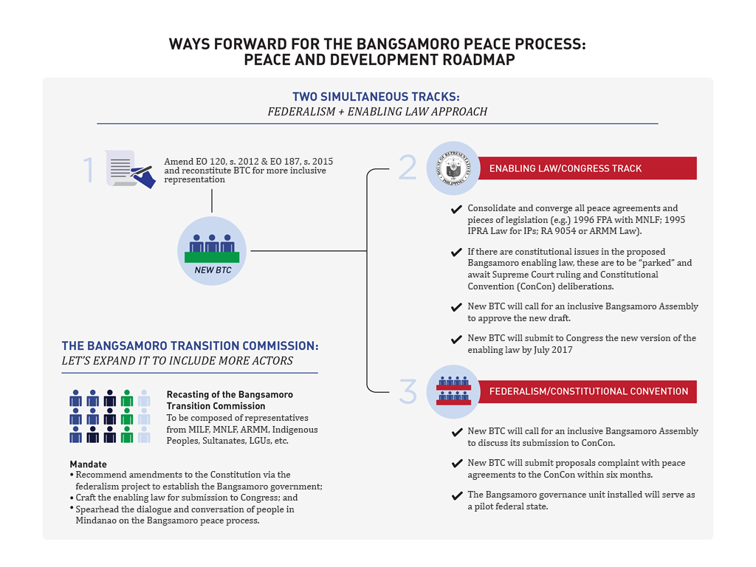
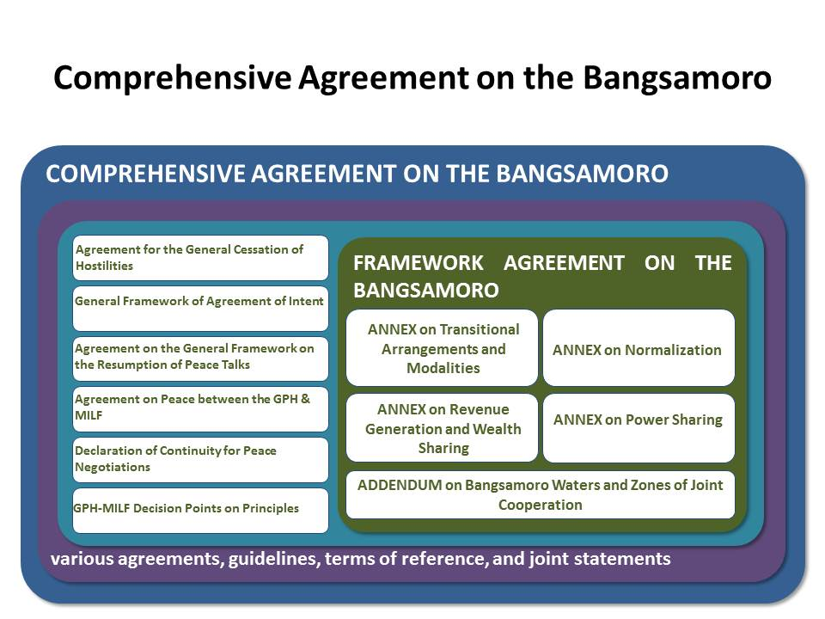

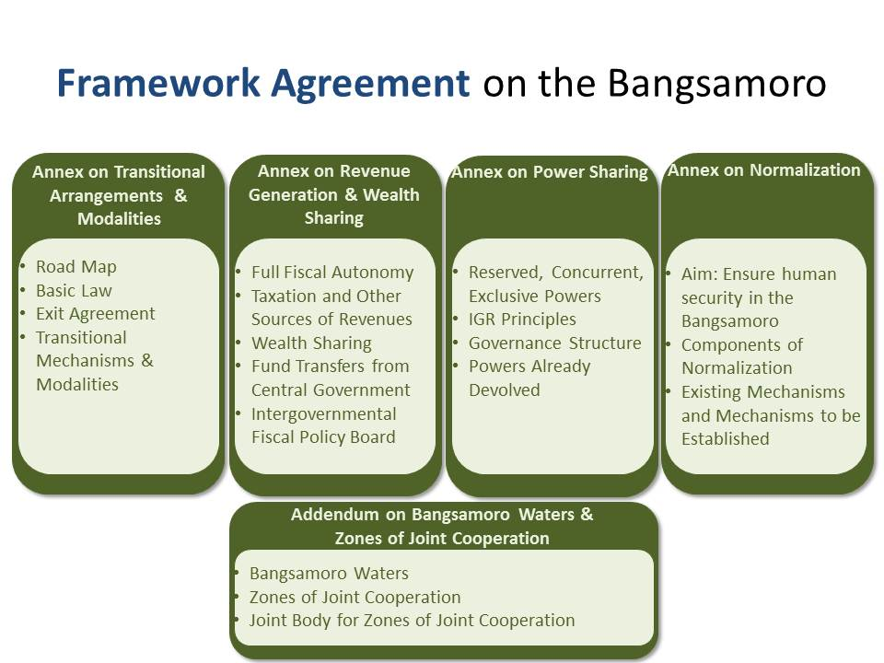

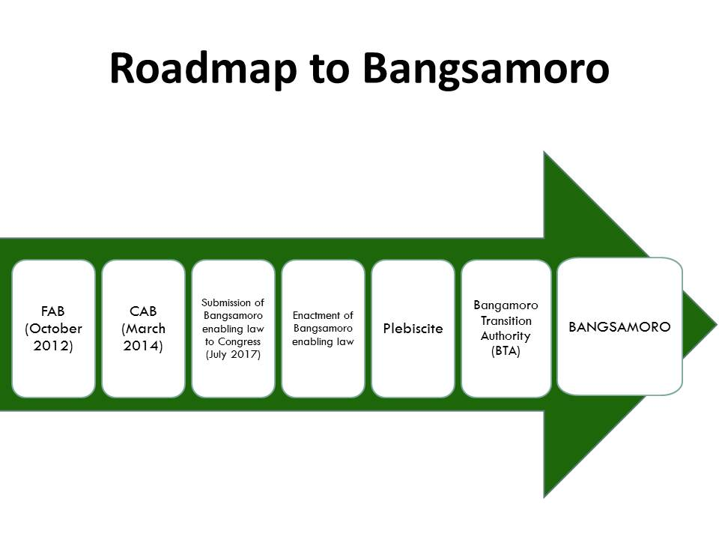

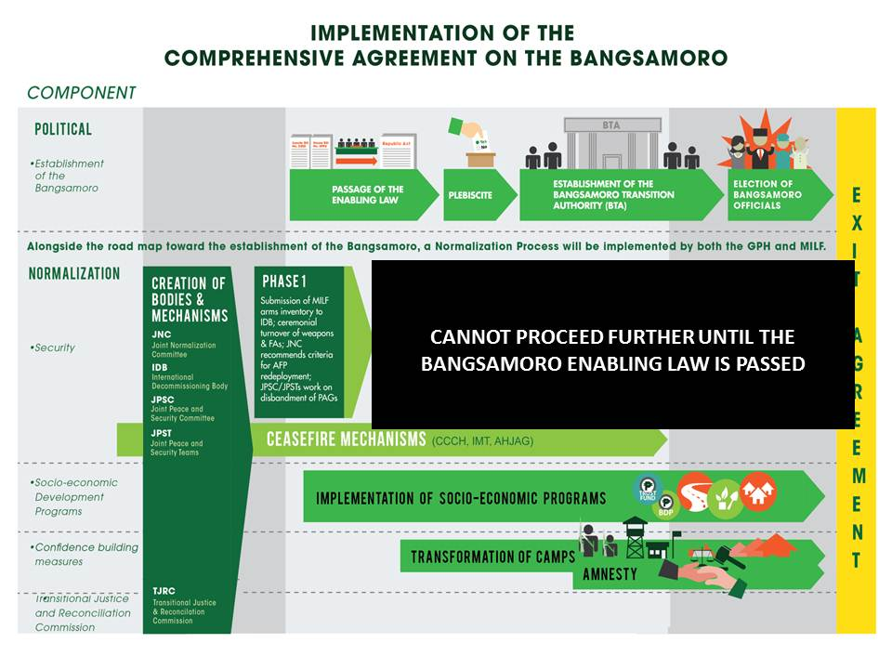

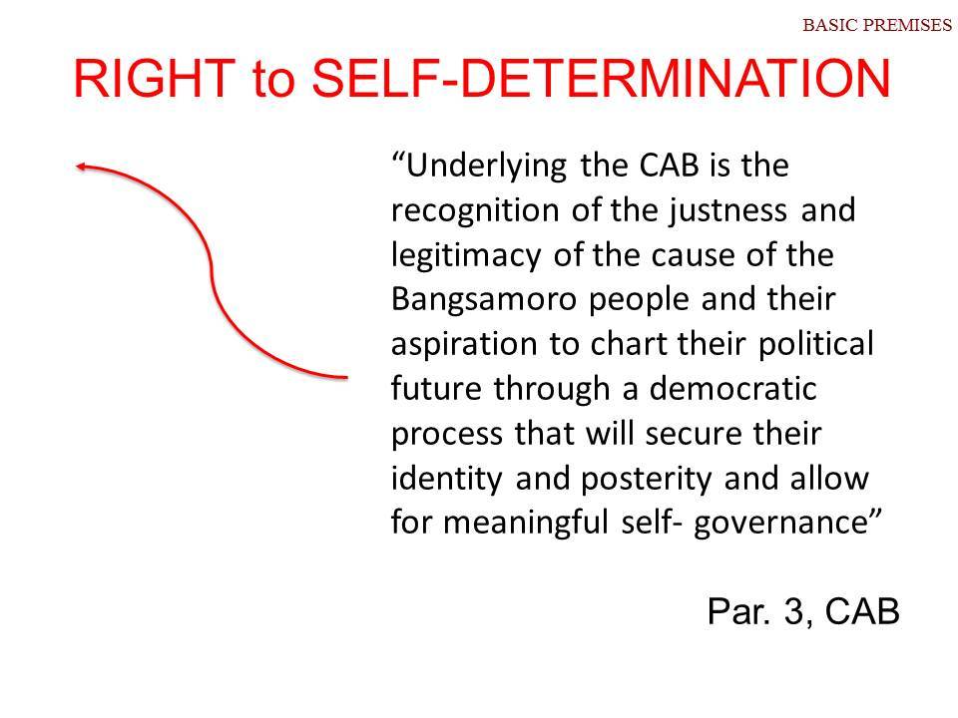

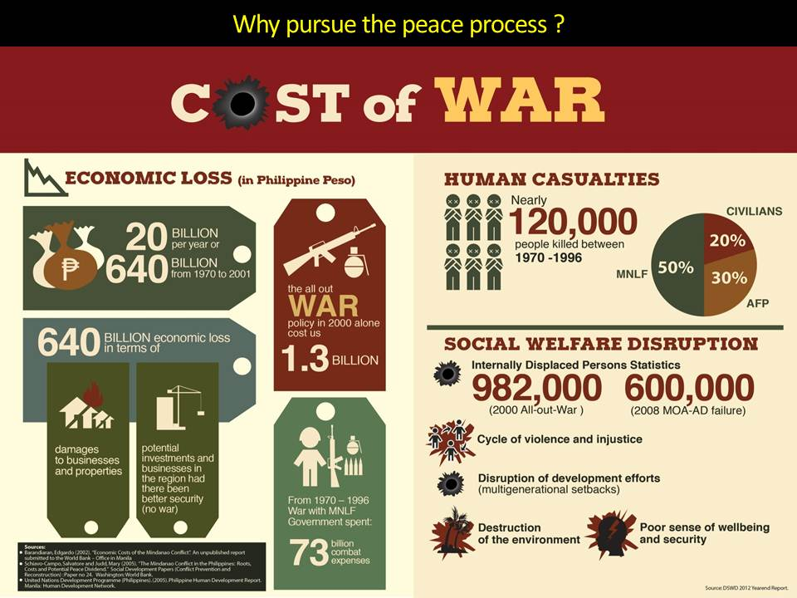
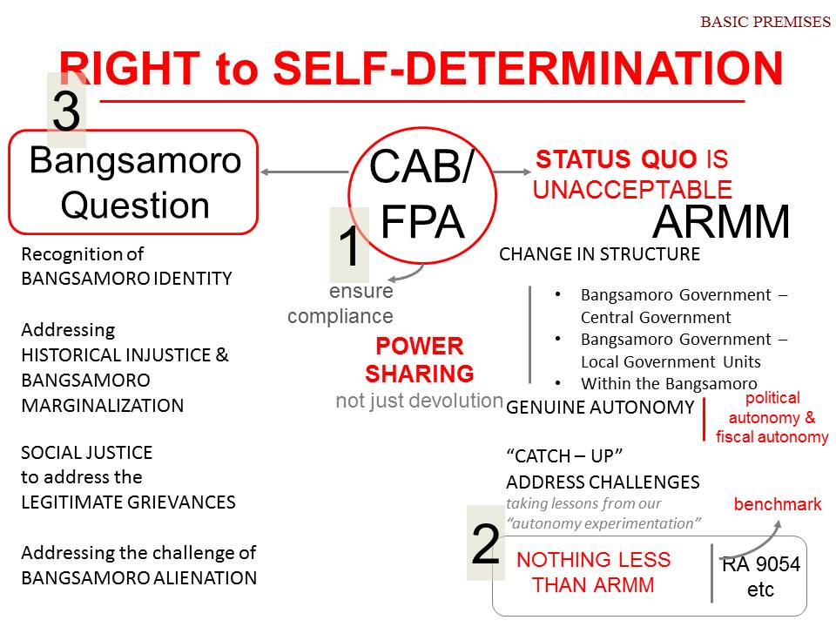

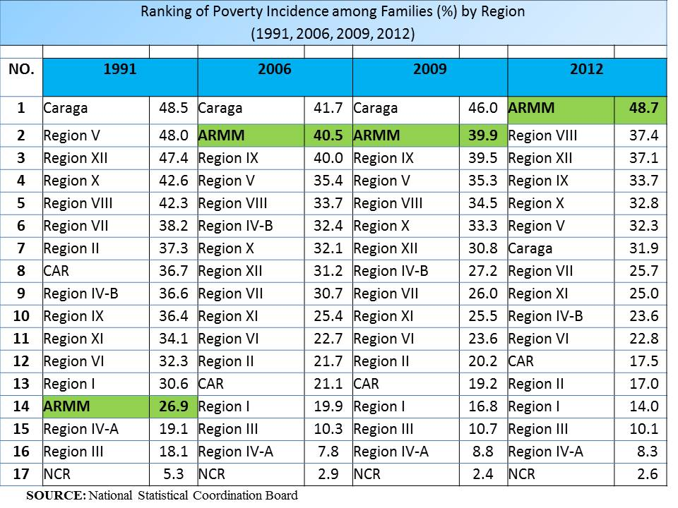

Why pursue the peace process ?

We are pursuing peace and stability in Muslim Mindanao through a negotiated political settlement to address:
  - Historical injustices committed against the Bangsamoro
  - Minoritization and landlessness
  - Relative economic deprivation and underdevelopment (bring lag regions like the Bangsamoro at par with the other more developed regions in the country)
  - Political and cultural marginalization
  - The just aspirations of the Bangsamoro people for self-determination while preserving and strengthening the territorial integrity of the Republic of the Philippines.

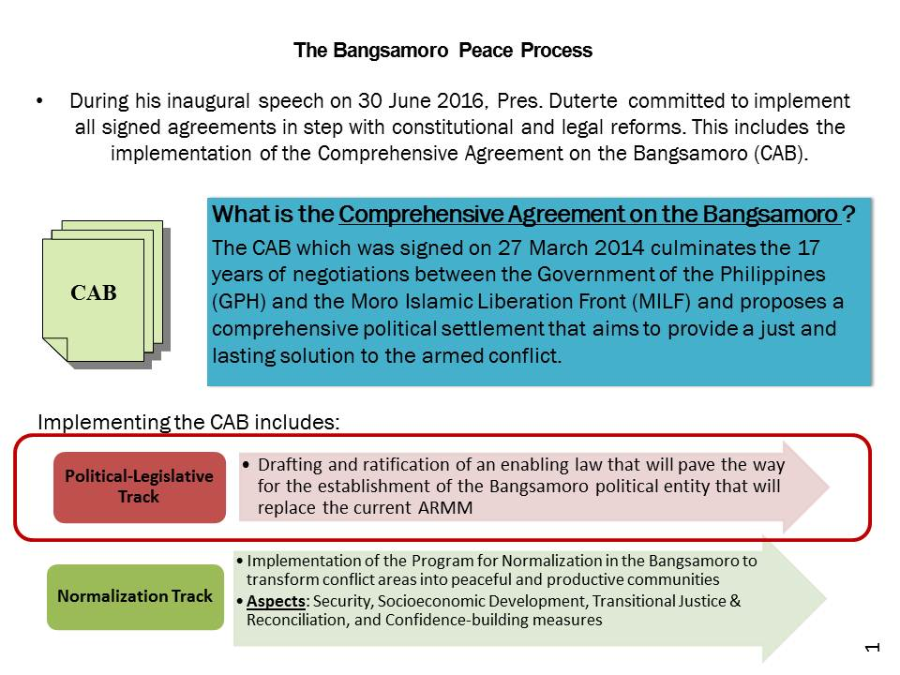
Drafting and Submission of the Bangsamoro Basic Law

7 Nov 2016 – Issuance of EO 8 on the creation of the new BTC with 21 members
  - 11 from MILF and 10 GPH (including 3 from MNLF-Jikiri/Sema Group), ARMM, Women, Academe, Settler Community, IPs, increased in representation and inclusive of all sectors.
10 Feb 2017 – PRRD named the 21 members of the BTC
24 Feb 2017 – BTC was officially launched in Davao City
17 June 2017 – BTC finalized its draft
17 July 2017 – BTC turned over the draft BBL to PRRD at the Malacanang Palace
26 Sept 2017 – Proposed BBL is filed as HB 6475 at the House of Representatives (authored by Speaker Alvarez, Majority Floor Leader Farinas, Minority Floor Leader Suarez, Deputy Speaker Sema, etc.)

Purpose of the Proposed Bangsamoro Basic Law

“The purpose of this Basic Law is to establish a political entity, provide for its basic structure of government in recognition of the justness and legitimacy of the cause of the Bangsamoro people and their aspiration to chart their political future through a democratic process
that will secure their identity and posterity and allow for meaningful self-governance.”
(BBL, Article I, Sec. 3)

Outline of the Bangsamoro Basic Law (BBL)

Preamble
Article I Name and Purpose
Article II Bangsamoro Identity
Article III Territory
Article IV General Principles and Policies
Article V Powers of Government
Article VI Intergovernmental Relations
Article VII The Bangsamoro Government
Article VIII Wali
Article IX Basic Rights
Article X Bangsamoro Justice System
Article XI Public Order and Safety
Article XII Fiscal Autonomy
Article XIII Economy and Patrimony
Article XIV Rehabilitation and Development
Article XV Plebiscite
Article XVI Bangsamoro Transition Authority
Article XVII Amendments and Revisions
Article XVIII Final Provisions

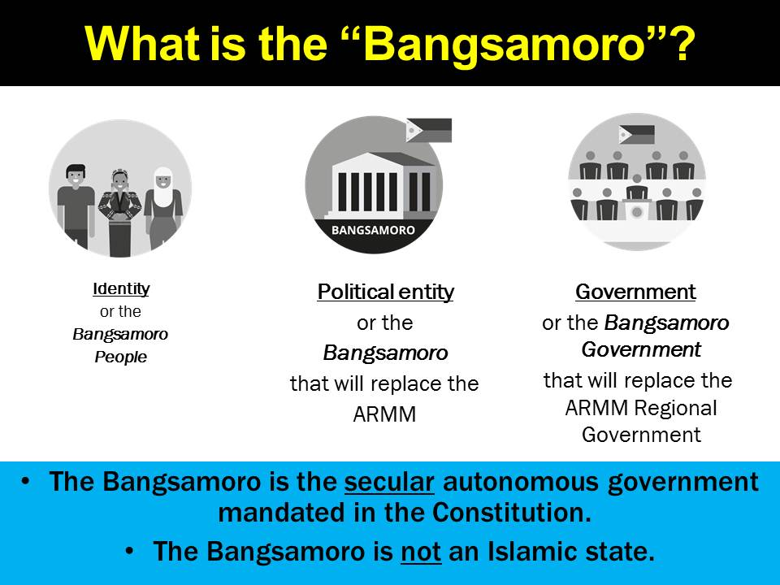

Bangsamoro Basic Law (BBL)

MYTHS VS. FACTS
MYTH: That the Bangsamoro will be an independent state separate from the Philippines, with its inhabitants having a citizenship different from the rest of the Filipinos.

FACT: The Bangsamoro will not be an independent state. It will remain part of the territory of the Republic of the Philippines and its inhabitants will remain Filipino citizens

Is the creation of the Bangsamoro
provided in the 1987 Constitution?
YES
The 1987 Constitution (Art. X, Sec. 15) provides for the creation of an autonomous region in Muslim Mindanao:
“There shall be created autonomous regions in Muslim Mindanao and in the Cordilleras consisting of provinces, cities, municipalities, and geographical areas sharing common and distinctive historical and cultural heritage, economic and social structures, and other relevant characteristics within the framework of this Constitution and the national sovereignty as well as territorial integrity of the Republic of the Philippines.”

The proposed BBL puts into life and spirit what is contemplated in the 1987 Constitution:

“The purpose of this Basic Law is to establish a political entity, provide for its basic structure of government in recognition of the justness and legitimacy of the cause of the Bangsamoro people and their aspiration to chart their political future through a democratic process that will secure their identity and posterity and allow for meaningful self-governance.” (BBL, Article I, Sec. 3)

MYTH: That the Bangsamoro identity is imposed on all inhabitants in the Bangsamoro areas irrespective of their socio-cultural and religious affinity and ancestry.

FACT: No, the Bangsamoro identity is not being imposed on anyone. Under the proposed BBL, people will have a right to choose to identify themselves as Bangsamoro.
The proposed BBL provides that “those who, at the advent of the Spaniards, were considered natives or original inhabitants of Mindanao and the Sulu archipelago and its adjacent islands including Palawan, and their descendants, whether of mixed or of full blood, shall have the right to identify themselves as Bangsamoro by ascription or self-ascription. Spouses and their descendants are classified as Bangsamoro” (Art. II, Sec. 1).
This means that a person has to claims himself or herself as Bangsamoro.
The proposed BBL also states that “the freedom of choice of other indigenous peoples shall be respected. There shall be no discrimination on the basis of identity, religion, and ethnicity.” (Art. II, Sec. 2)

MYTH: That inclusion in the proposed Bangsamoro requires only a local government unit (LGU) resolution or petition of 10 % of the registered voters in the area.

FACT: NOT TRUE. The LGU resolution or the petition of 10% of qualified voters will only be for the purposes of being included in the plebiscite. A majority vote is still needed for an LGU to be included in the Bangsamoro territory upon its creation.
Areas that are outside the proposed core territory may be included in the plebiscite to ratify the BBL and be part of the Bangsamoro if the following are met:
- Area must be contiguous to the core territory; and
- At least two (2) months prior to the plebiscite, there is either a:
  - Resolution of the concerned local government units (LGUs) asking for participation in the plebiscite, or
  - Petition of at least ten percent (10%) of the registered voters in the area asking to be included in the plebiscite.

Areas where the plebiscite will be conducted
The establishment of the Bangsamoro shall take effect upon the ratification of the BBL by majority of the votes cast in a plebiscite in:
  - Present ARMM (Maguindanao, Lanao del Sur, Basilan, Sulu, Tawi-Tawi, Marawi City, Lamitan City)
  - 6 municipalities of Baloi, Munai, Nunungan, Pantar, Tagaloan and Tangkal in Lanao del Norte
  - 39 brgys in Kabacan, Carmen, Aleosan, Pigkawayan, Pikit, and Midsayap in North Cotabato
  - Cotabato City and Isabela City
  - Other contiguous areas where there is a resolution of the local government unit or a petition of at least ten percent (10%) of the registered voters in the geographic area asking for their inclusion at least two (2) months prior to the conduct of the ratification of the Basic Law.
The plebiscite shall be conducted, not earlier than 90 days or later than 120 days after the effectivity of the Basic Law. (BBL, Art. XV, Sec. 2)

DELIMITATION OF THE BANGSAMORO

A plebiscite shall be held in areas which were not able to join in the Bangsamoro 5 years after the ratification of the BBL and every 5 years thereafter for a period of 25 years, to determine whether or not they desire to join the Bangsamoro (Art. XV, Sec. 4).
Contiguous areas mentioned in the 1976 Tripoli Agreement and the 1996 Final Peace Agreement may opt to join the Bangsamoro through a period plebiscite, provided that a petition signed by 10% of the registered voters or a resolution of the LGU of each province, city, municipality or other contiguous geographic area opting to join is submitted to their respective election office at least 1 year prior the scheduled plebiscite (Art. XV, Sec. 4).
At the end of the 25th year, the Bangsamoro shall have been delineated and delimited, no other plebiscite for expansions shall be held (Art VX, Sec. 5).

MYTH: That the Bangsamoro will be an Islamic state where Shari’ah law will be applied to all of its inhabitants, Moros, Christians and Lumads alike.

FACT: NOT TRUE. There is nowhere in the proposed BBL that an Islamic State is mentioned, even more so to be established.

There shall be a plurality of justice system in the Bangsamoro consisting of:
  - Shari’ah law which shall have supremacy and application over Muslims only
  - the traditional or tribal justice system, for the indigenous peoples in the Bangsamoro
  - the local courts
  - alternative dispute resolution system

MYTH: That the Bangsamoro will have its own armed forces, foreign policy, and currency.

FACT: NOT TRUE. It is clearly stated in the proposed BBL that defense and external security, foreign policy, coinage and monetary policy, among others, are reserved powers of the Central Government. Therefore, the Bangsamoro will not have its own armed forces, foreign policy and currency (see BBL, Art. V, Sec. 1).
NOTE: Other reserved powers of the Central Government are: postal service, citizenship and naturalization, immigration, customs and tariff, common market and global trade, and intellectual property rights.

MYTH: That the proposed parliamentary form of government in the Bangsamoro is unconstitutional.

FACT: A parliamentary form of government in the Bangsamoro is possible under the 1987 Constitution.
The Constitution does not prescribe a particular form of government for the autonomous regions. It only provides that “the organic act shall define the basic structure of government for the region consisting of the executive department and legislative assembly, both of which shall be elective and representative of the constituent political units” (Art. X, Sec. 18).

A parliamentary form of government satisfies these conditions. The legislative authority shall fall on the Bangsamoro Parliament composed of party representatives, district representatives, and reserved seats and sectoral representatives, to be chosen by the voters in the Bangsamoro. The head of the government, the Chief Minister, shall be elected by a majority vote of the Bangsamoro Parliament from among its members. The Chief Minister is thus an elected official.

Is a parliamentary form of government allowed under the 1987 Constitution?
1987 Constitution, Art. X, Sec. 18. “The Congress shall enact an organic act for each autonomous region with the assistance and participation of the regional consultative commission composed of representatives appointed by the President from a list of nominees from multi-sectoral bodies. The organic act shall define the basic structure of government for the region consisting of the executive department and legislative assembly, both of which shall be elective and representative of the constituent political units. The organic acts shall likewise provide for special courts with personal, family, and property law jurisdiction consistent with the provisions of this Constitution and national laws.”
- 14 of 18 surviving Framers of the 1987 Constitution also affirm that a parliamentary form of government is allowed in the Constitution.
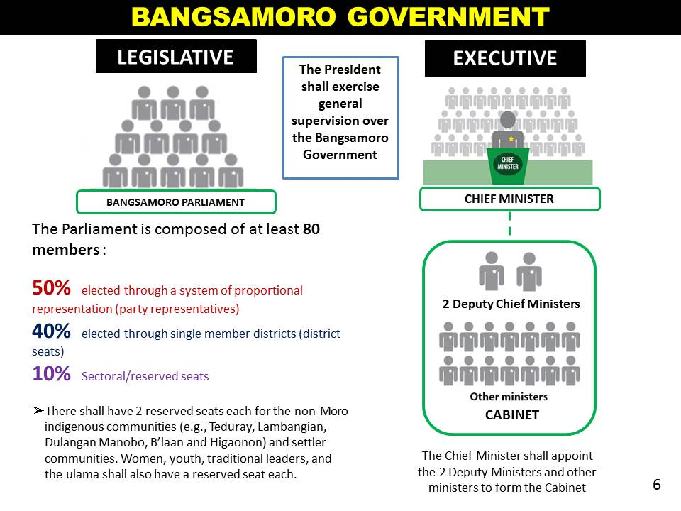
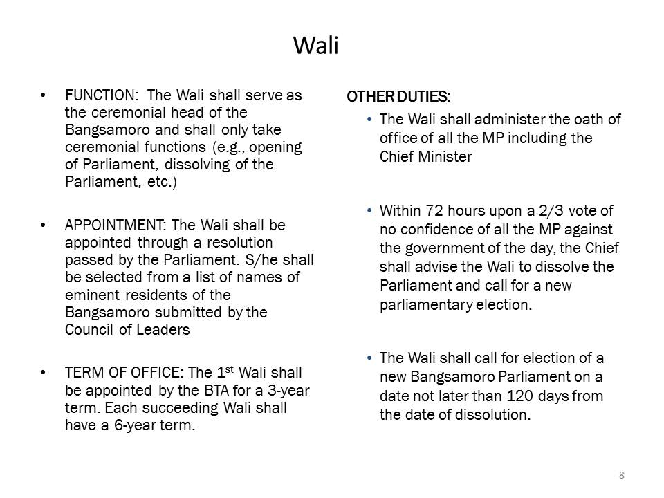
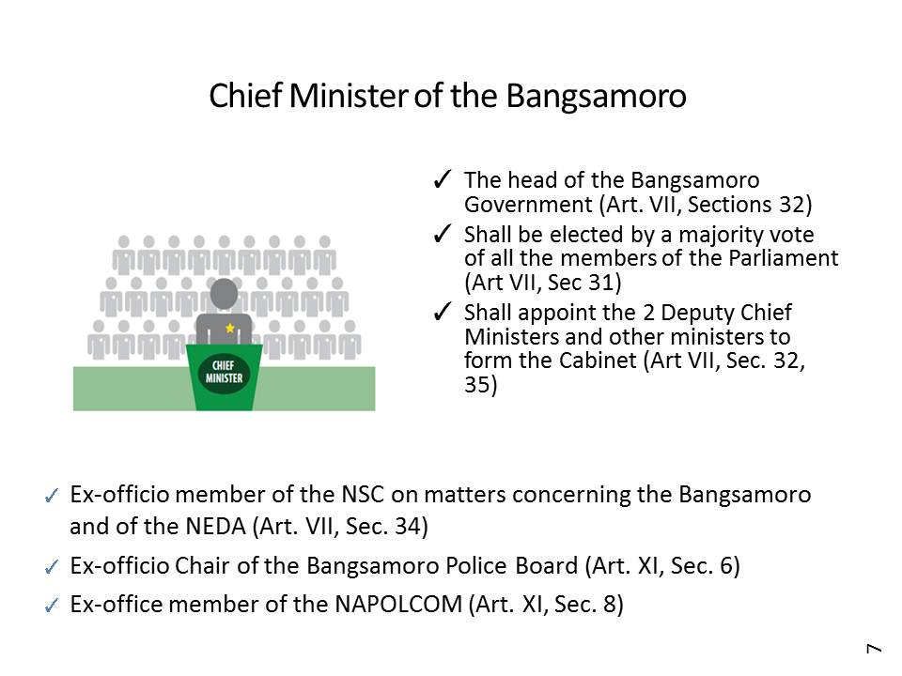
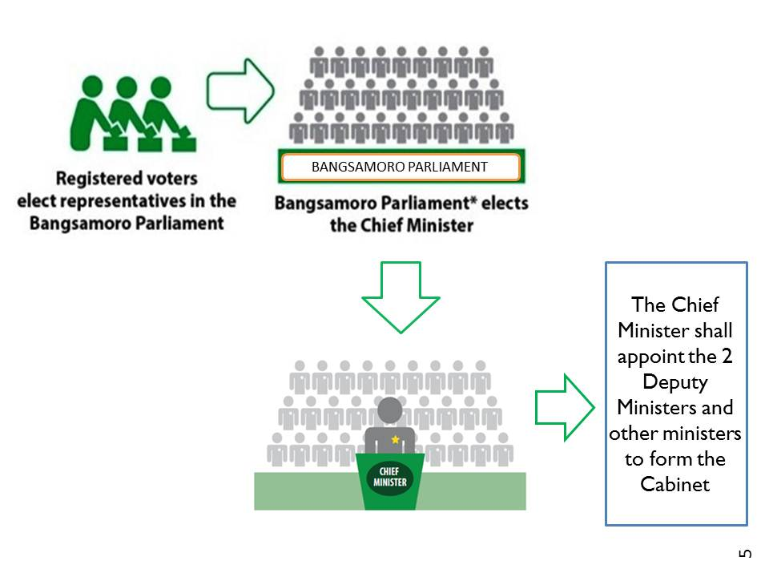

MYTH: That the Moro Islamic Liberation Front (MILF) will automatically replace the police in the Bangsamoro areas (former ARMM) and that the Bangsamoro Police will be independent from the Philippine National Police.

FACT: NOT TRUE. The MILF will not replace the police force in the Bangsamoro. The Bangsamoro will not have a separate police. There shall be only one police force in the country and the Bangsamoro Police “shall be part of the Philippine National Police” (see Art. XI on Public Order and Safety).
- The Bangsamoro police force shall be a regional unit of the Philippine National Police. All regions have the same such regional commands, including the ARMM today.
  - There is no automatic/wide-scale INTEGRATION of the MILF combatants to the PNP or the AFP. If they wish to apply, they will have to comply with the requirements set by the national PNP or the AFP.

MYTH: That the Bangsamoro will have its own COA, COMELEC, Civil Service and CHR.
FACT: NO, the Bangsamoro will not have its own constitutional commissions.
- The Bangsamoro Commission on Audit shall be created without prejudice to the power of the COA.
- Bangsamoro auditing body – internal audit already present in all government agencies, LGUs, etc.
- Bangsamoro Electoral Office is regional office of COMELEC, performing the functions of the COMELEC in the Bangsamoro
- Bangsamoro Civil Service office is similar to human resources office of other agencies
- Bangsamoro human rights commission is existing in ARMM. The creation of a Regional Human Rights Commission is already provided in RA 9054

All without prejudice to the existence, mandate and authorities of the constitutional bodies

MYTH: That the Government is providing a lot of money to the Bangsamoro through expansion of Bangsamoro’s fiscal powers

FACT: The goal of enhancing fiscal autonomy and wealth sharing in the proposed Bangsamoro is to promote social justice and development through equitable distribution of opportunities, income and wealth in conflict-affected Muslim Mindanao – an area which have economically lagged after years of armed conflict and relative economic deprivation. The proposed BBL aims to give the future Bangsamoro greater fiscal autonomy through appropriate funding mechanisms to allow it to become self-sufficient, as well as to enable it to adequately exercise its powers and functions consistent with the principles of autonomy.

MYTH: That land rights of other indigenous peoples and inhabitants are not protected.
FACT: Under the proposed BBL, “vested property rights shall be recognized and respected” (Art. IX, Sec. 3). The BBL also expressly recognizes and protects the rights of the indigenous peoples (IPs) to their native titles and/or fusaka inged, including their right to equitable share in the revenues from the utilization of natural resources, their preferential rights in the exploration, development, and utilization of such natural resources, and their right to free and prior informed consent in relation to all development initiatives therein.

MYTH: That only the Bangsamoro will be allowed to exploit, develop and utilize natural and other aquatic resources found in the Bangsamoro waters and Zones of Joint Cooperation (ZJC).

FACT: Bangsamoro waters which is found in parts of Sulu Sea and the Moro Gulf are part of the territorial waters of the Philippines and are for the benefit of all Filipinos.
Preferential rights for local fishers are subject to regulation by the Bangsamoro Government and the respective LGUs with respect to their municipal waters.
The Zones of Joint Cooperation (ZJC) in the Sulu Sea and the Moro Gulf outside of the Bangsamoro waters are not part of the Bangsamoro’s jurisdiction. It is only established for:
  - The protection of the traditional fishing grounds,
  - Benefitting from the resources, and
  - Interconnectivity of the islands and the mainland parts of a cohesive Bangsamoro political entity.
The ZJC remain available to all Filipino citizens but the preferential rights of the Bangsamoro people, other indigenous peoples in the adjoining provinces, and resident fishers in the Bangsamoro over fishery, aquamarine, and other living resources in the ZJC shall be respected.

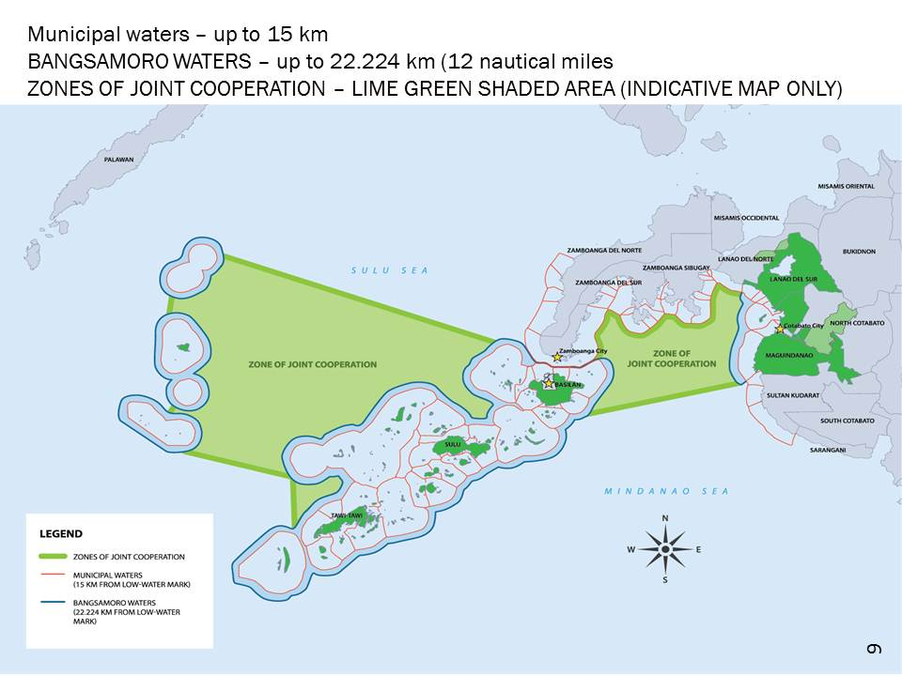

Notes were taken from the enhanced BBL presentation by the Bangsamoro Transition Commission (BTC)

